[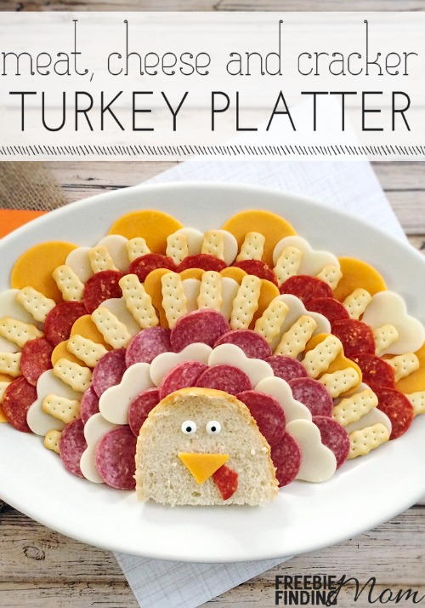](http://www.freebiefindingmom.com/wp-content/uploads/2015/10/meat-cheese-cracker-turkey-platter-pin.jpg)

DIRECTIONS

1. Slice off a 5″ piece of French bread.

2. Cut the piece of bread in half crosswise (see image below) and place it on the platter with the jagged (cut) side at the bottom of the platter.

3. Take a piece of cheddar cheese and cut out a small triangle; place it in the middle of the French bread (for the Turkey’s nose).

4. Take a piece of pepperoni, cut a small piece off, and place it so that it “pokes out” from under the piece of cheddar cheese.

5. Place 2 candy eyes above the triangle; now the piece of French bread should look like a turkey’s face

6. Place a row of hard salami around the bread.

7. Use half of the bone shaped cookie cutter to cut the mozzarella cheese (see image below).

8. Use the round end of the snowman cookie cutter to cut the cheddar cheese (see image below).

9. At the top of the platter, begin fanning out your cut cheeses alternating between cheddar and mozzarella.

10. Place a row of club crackers so that they overlap the cheese; leaving spaces between your crackers (see image below)

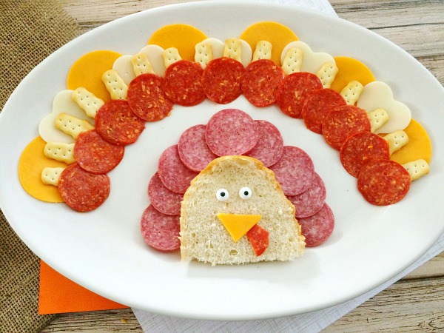

11. Place a row of pepperoni below the club crackers (overlapping slightly)

12. Keep rotating your different cheeses, club crackers, and meats around the French bread (turkey’s head).

[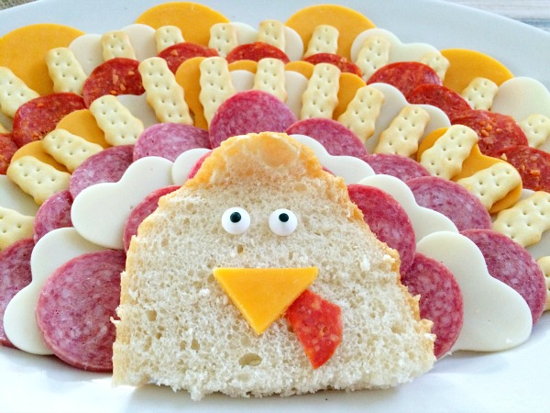](http://www.freebiefindingmom.com/wp-content/uploads/2015/10/meat-cheese-cracker-turkey-platter-final.jpg)